Pre-requisites

|  |  |
| --- | --- |
| Date | 19 September 2022 |
| Team ID | PNT2022TMID27630 |
| Project Name | VirtualEye - Life Guard for Swimming Pools to Detect Active Drowning |
| Maximum Marks | 4 Marks |

**INSTALLATION OF PYTHON 3.7.4**

STEP 1: Type python in google and click on the first link.

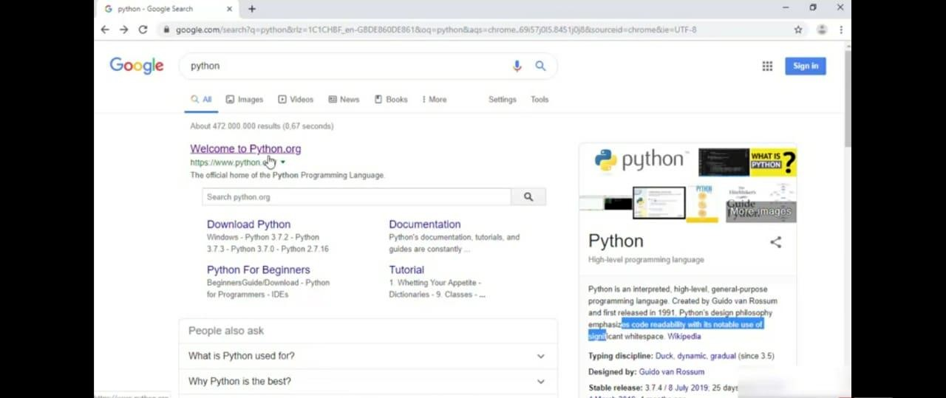

STEP 2: Click the python 3.7.4

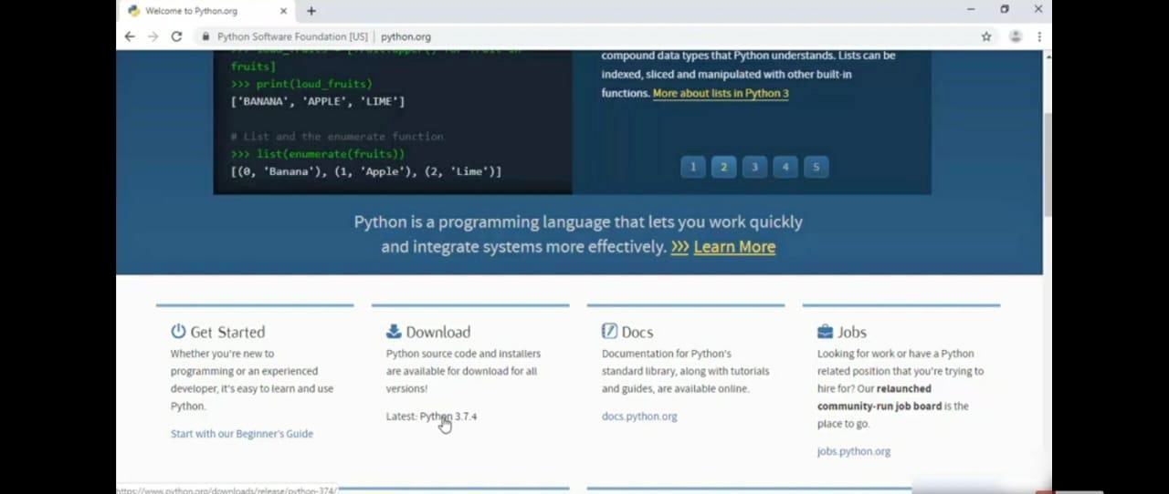

STEP 3: Scroll down to reach the Files and click windows x86-64 executable installer.

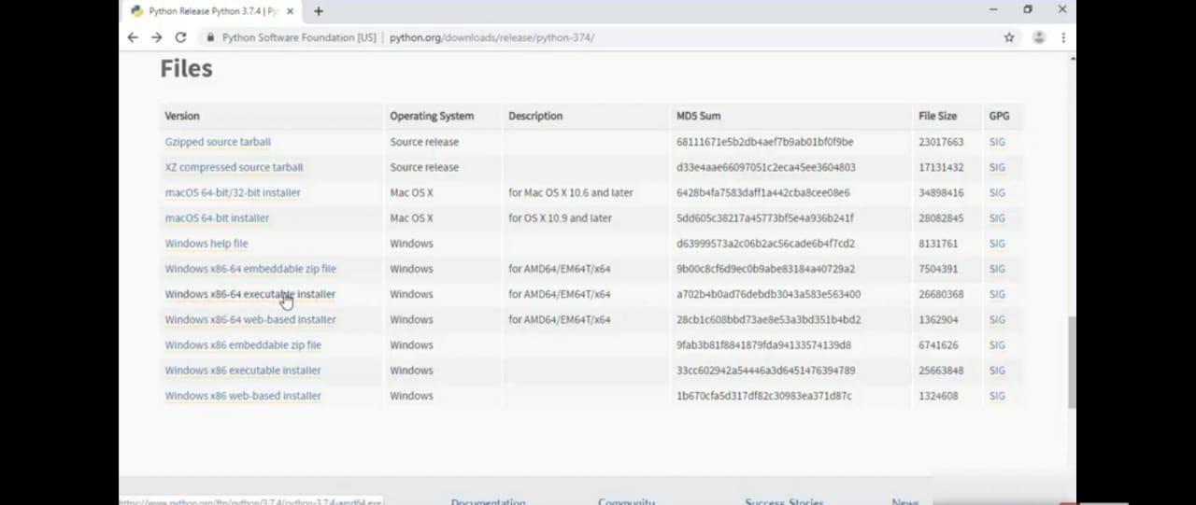

STEP 4: Click on the executable file.

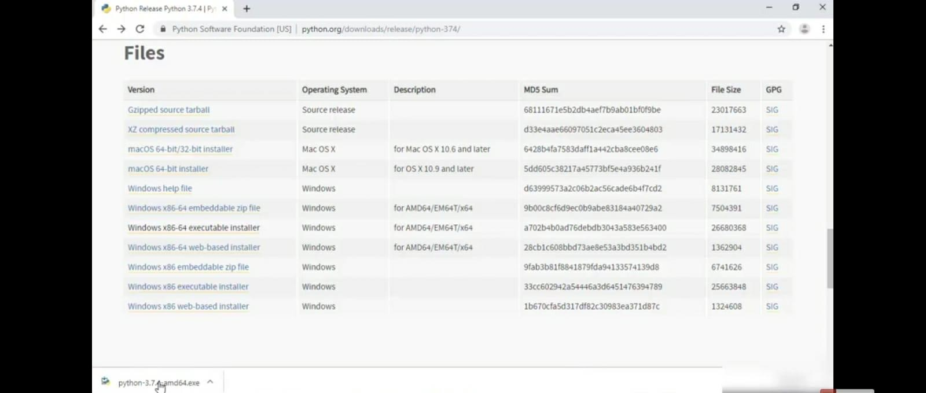

STEP 5: Click on the Run button.

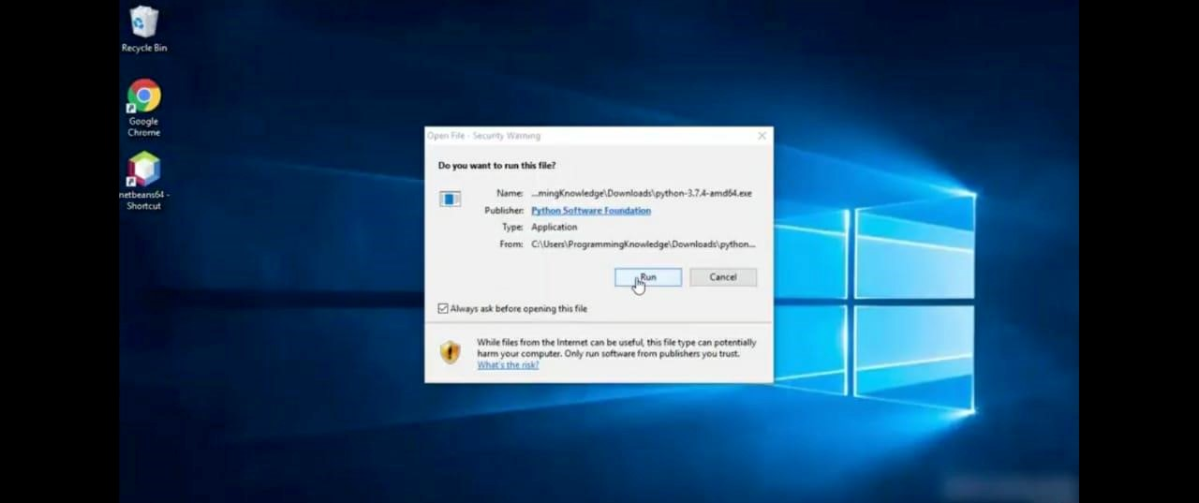

STEP 6: To change the path click on the second check box Add python 3.7 to PATH and then click the customize installation.

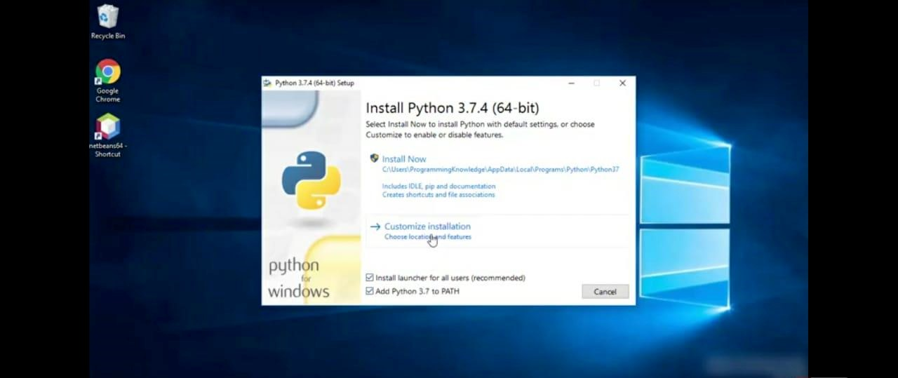

STEP 7: Click the Next button.

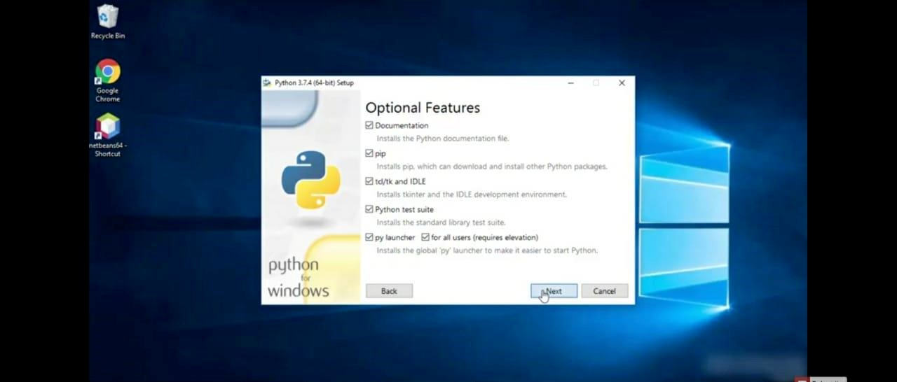

STEP 8: You can change the path here and click on the install button.

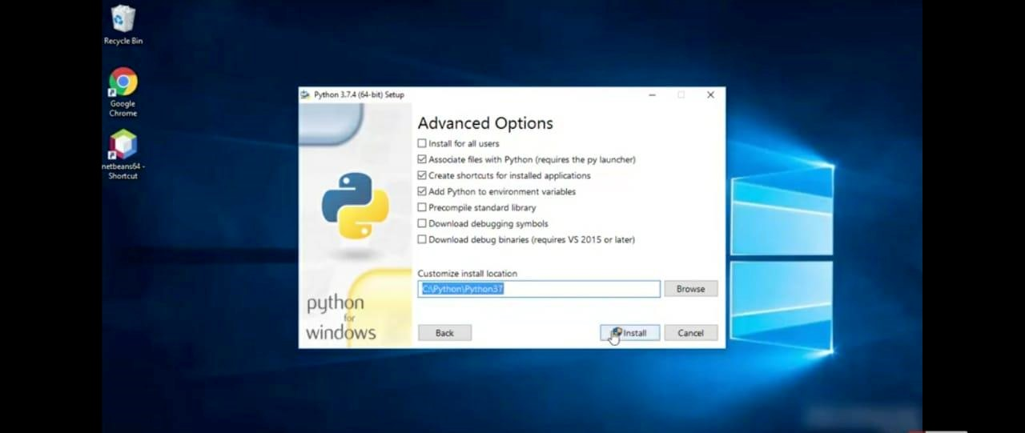

STEP 9: Installation process.

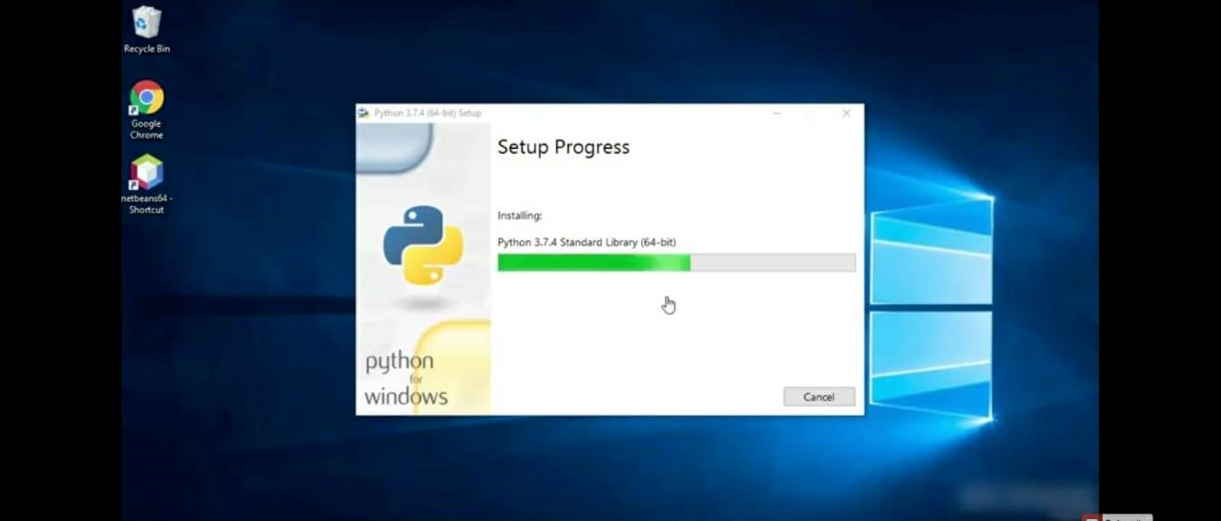

STEP 10: Click Yes button.

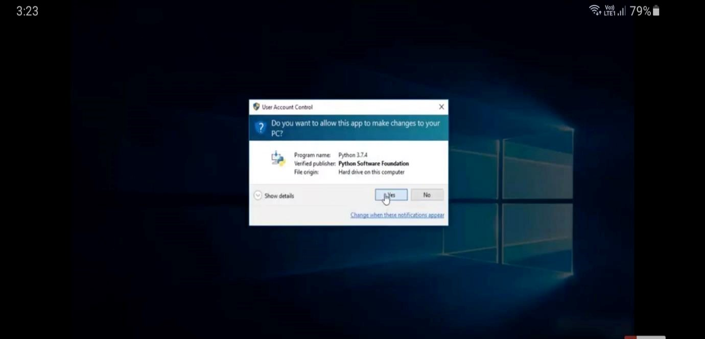

STEP 11 Click the close button.

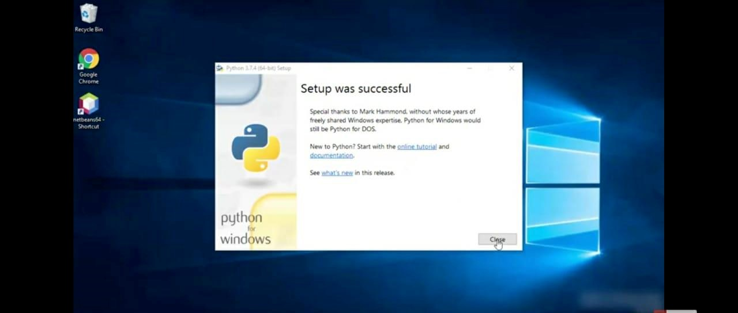

STEP 12: To check whether it is working click the windows icon , click the All apps.

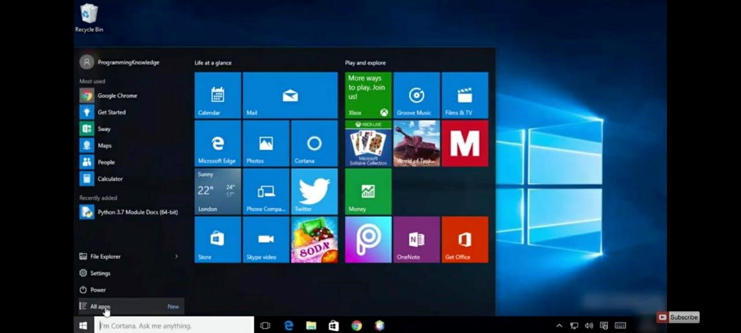

STEP 13 Click the IDLE (python 3.7 64-bit).

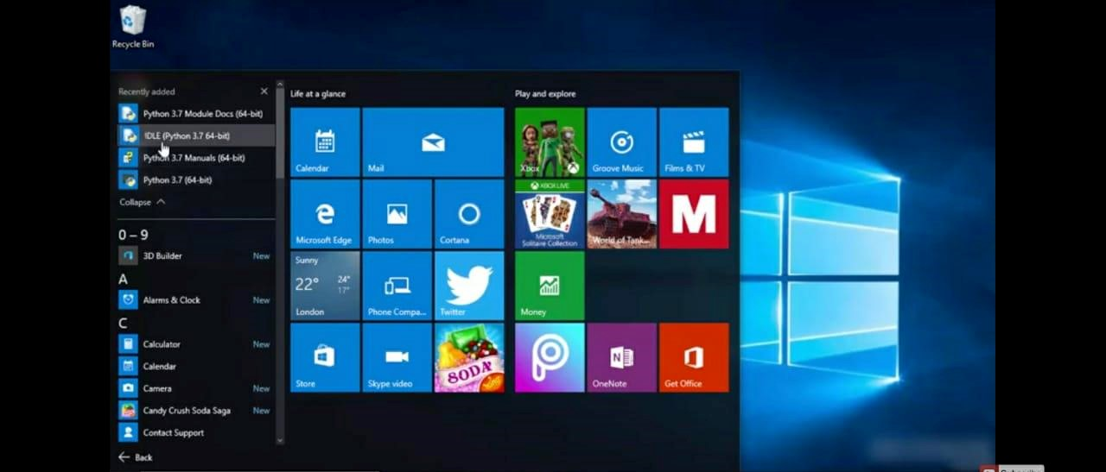

STEP 14: This is the IDLE window.

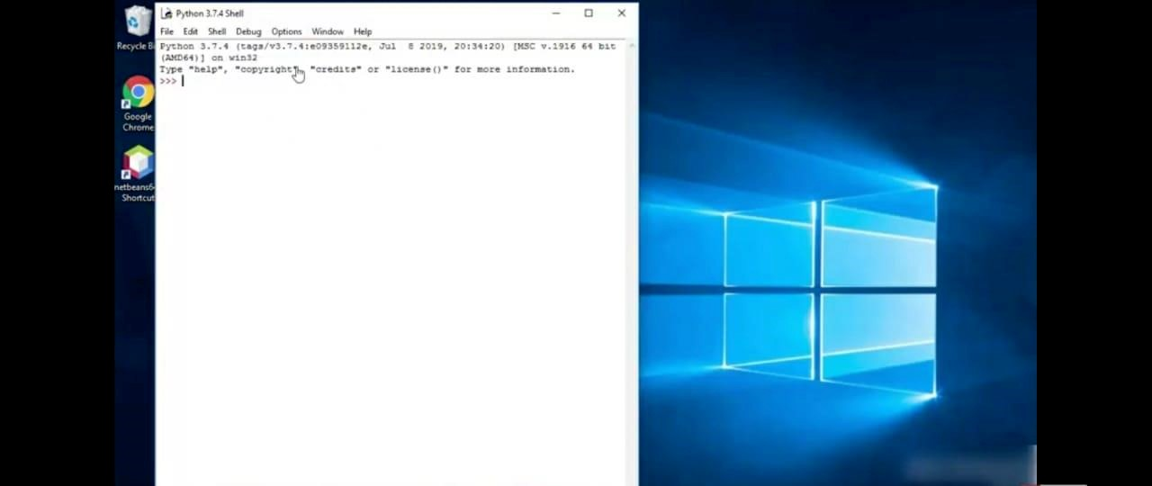

STEP 15 Click the Python 3.7 (64-bit).

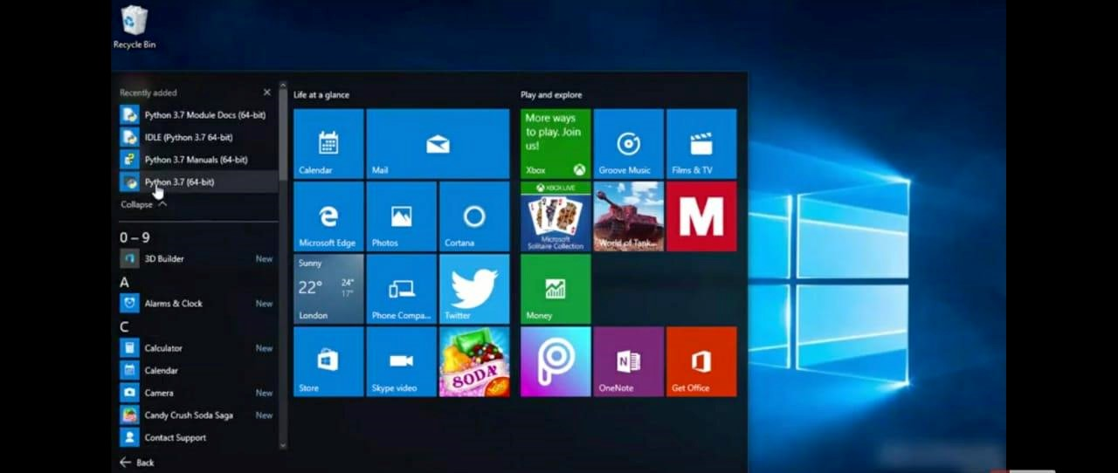

STEP 16: This is the Python 3.7 (64-bit) command prompt.

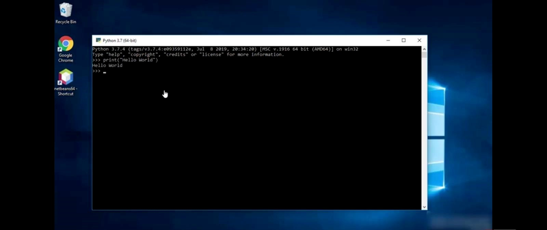

STEP 17: To check whether the python works with windows command prompt. Right click the windows icon.

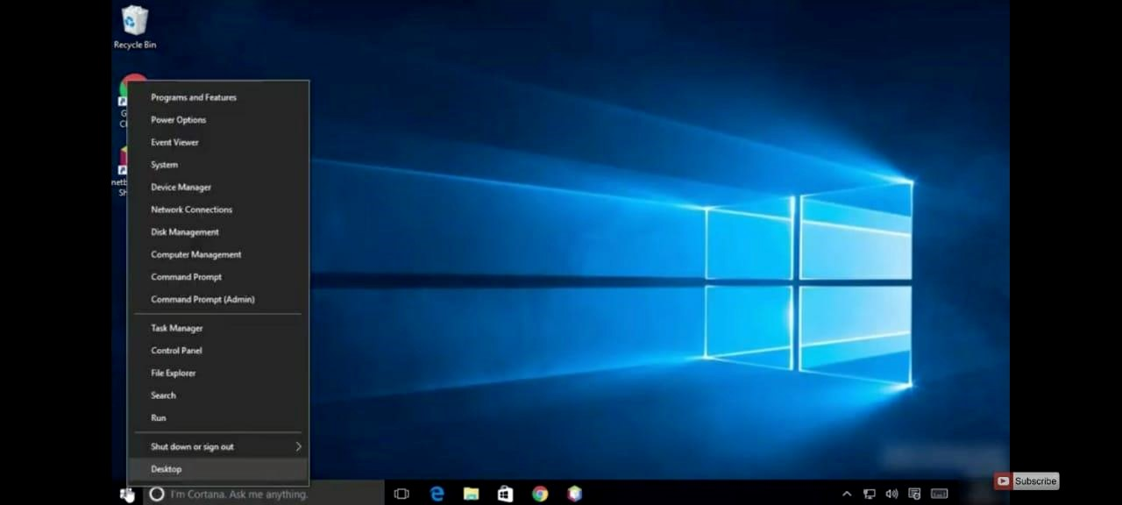

STEP 18: Click the command prompt.

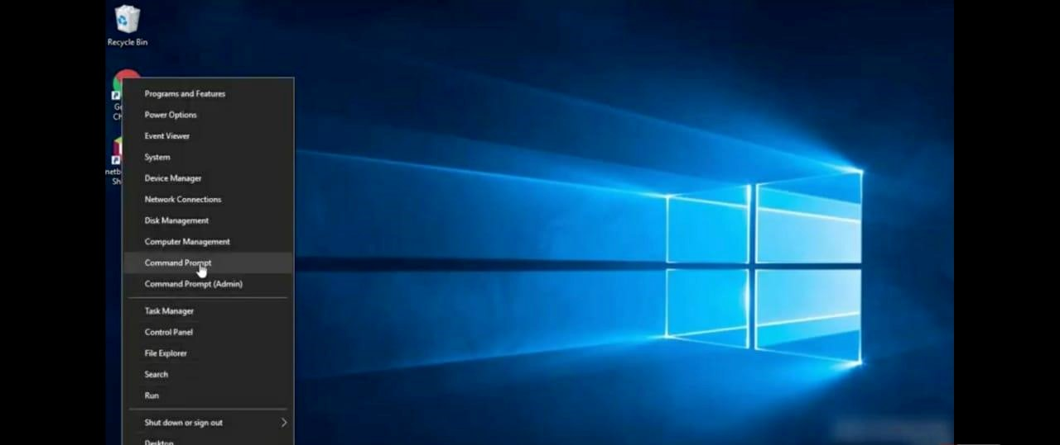

STEP 19: Type Python in the command prompt and check whether it is working.

